Title | Digital Output Software System Design Description
Distribution | Software Archive
Author | Paul Li  Vincent Liu | Date | 2013-12-06
Review | See review section | Date | See review section
Approved |  | Date
Remarks

Contents

1 Context 3
1.1 Overview 3
1.2 Pulse/Frequency Output Concept 4
1.3 Use Case Diagram 6
1.4 Subsystem Definitions 6
1.5 Acronyms and Abbreviations 7
2 Data Sheet 8
3 Detailed Description 10
3.1 Static Modelling 10
3.2 Dynamic Modelling 11
3.3 Class Design 14
3.4 Detailed Design 15
3.5 Design Decisions and Limitations 19
3.5.1 Frequency generating algorithm 19
3.5.2 Pulse generating algorithm 19
3.5.3 Limit Pulse factor Dynamic Limits 20
3.5.4 Limit Pulse Width Dynamic Limits 20
3.6 Parameter configuration algorithm 22
3.7 Hardware Dependencies 22
3.8 Memory Usage 23
3.9 Data Object Description 23
4 References 27
5 Revision History 27
6 Design Review 27
6.1 Review-Participant: 27
6.2 Decision of the Review: 27
6.3 Check list: 27
6.4 Remarks: 27
6.5 Defects 27
6.6 Changes are proved: 28

List of Figures
Figure 1: Use Case Diagram for Digital Output Subsystem 6
Figure 2: Context Diagram for Digital Output Subsystem 10
Figure 3: Collaboration diagram for Set Logic Output 11
Figure 4: Collaboration diagram for Update Freq Output 12
Figure 5: Collaboration diagram for Update Pulse Addition Count 13
Figure 6: Collaboration Diagram for Configure Digital Outputs 14
Figure 7: Digital Output subsystem class diagram 15
Figure 8: Activity diagram for Update Digital Output Actions 16
Figure 9: Activity diagram for Update Freq Output ISR 17
Figure 10: Activity diagram for Update Pulse Output ISR 18

Context
This document is a representation of analysis, planning, implementation and decision-making for the VT5 project’s Digital Output subsystem. One of its major goals is to support reuse of the described subsystem.

The document is divided into two main parts:

- The first part is a data sheet intended for developers that want to reuse the subsystem, listing important issues from a black-box view.

- The second part provides a more detailed subsystem description, including design information to allow subsystem maintenance or future expansion.

Overview
This document describes the functional design specification for the Digital Output subsystem of VT5 flow meter project (see Digital Output Subsystem Requirements Specification Error: Reference source not found).

The Digital Output subsystem provides up to 1 digital signal for output on dedicated hardware port-lines. The signal-source for these digital outputs is derived from a supplied configuration, typically from HMI or HART, or similar although can be any external user-interface. Briefly this can be a simple active low/high alarm, or in the case of Digital Outputs 1, it can be a pulse-train representing the current flow value in terms of a user selectable standard or custom unit.

The following table summarises the options available:

Feature | Digital Output Subsystem
Number of HW Outputs | 1
HW Output Designation(s) | DO1*
Logic Output Configuration | Yes
Logic Output Simulation | Yes
Pulse Output Configuration | Yes
Pulse Output Simulation | Yes
* DO (Digital Out) is the port pin of the M16C

Pulse/Frequency Output Concept

The Digital Output subsystem outputs a continuous pulse-train (4) of frequency proportional to the received flow-rate (2) value. This output is recalculated whenever an update is invoked by the MVM Subsystem, which provides the Digital Output subsystem the flow-rate (in l/sec).

Totalizer
Subsystem
MVM
Subsystem
(1) flow-rate
(3) flow-total
HMI (Display)

HW Output: Logic Out

Digital Output
Subsystem
(2) flow-rate (l/s & kg/sec)
HW Output: Pulse Out

HW Output: Freq Out

Proposed Digital Output concept for this Design Solution

The detailed operation is as follows:

In order to reduce the overall CPU and interrupt load for the M16C the pulse generation is done via a timer cascade of 4 hardware timers:

- Frequency timer (Timer B2) is used for the generation of the base frequency used for pulse output, also the trigger of justify timer.
- Pulse count timer (Timer A0) is used to count the number of generated pulses and to trigger an underflow interrupt if the required number of pulses have been generated
- Pulse width timer for (Timer A4) is used to generate the correct mark length of the individual pulses
- Freq width justify timer for (Timer A1) is used to dynamic change the base timer( B2 ) registers

The timer hardware is programmed to connect the individual timers in the way described in the following paragraph and diagram:

Pulse Output Mode:

The timer B2 is running in ‘Timer mode’ in order to continuously generate a frequency signal (depending on the actual flow rate) that triggers the start of the pulse width timers and also serves as the source for the pulse count timer.
The pulse width timer for forward flow (Timer A4) operates in ‘One-Shot mode’ and takes the B2 signal as its trigger source. For the generation of the different pulse lengths the timers are using the main clock with an appropriate divider that keeps the counter values within 16 bits.
The interrupt for Timer A4 are disabled, since there is no need to perform any actions after each individual pulse generation.
Finally the pulse count timer (Timer A0) is operated in ‘Event counter mode’ and is also using the timer B2 signal as its input. The timers counter value is loaded with the number of pulses to be generated and an interrupt is triggered if an underflow occurs. The interrupt handler will then stop the current pulse generation by simply disabling the frequency and pulse count timers.

Frequencies Output Mode:

The timer B2 is running in ‘Timer mode’ in order to continuously generate a frequency signal (depending on the actual flow percent) that triggers the start of the timer A4.
The pulse width timer for forward flow (Timer A4) operates in ‘Event Counter Mode’ and takes the B2 signal as its trigger source. For the generation of the different Frequency the timers are using the main clock with an appropriate divider that keeps the counter values within 16 bits.
The interrupt for Timer A4 are disabled, since there is no need to perform any actions after frequency generation.
Finally the frequencies justify timer (Timer A1) is operated in ‘Event Counter mode’ and takes the B2 signal as its trigger source. The timers counter value is loaded with the number of pulses to be generated and an interrupt is triggered if an underflow occurs. The interrupt handler will change the base timer (B2) register and also the own register value(TA1).

Use Case Diagram
The following Use Case diagram illustrates the top-level uses derived in the Digital Output Subsystem Requirements Specification [1].

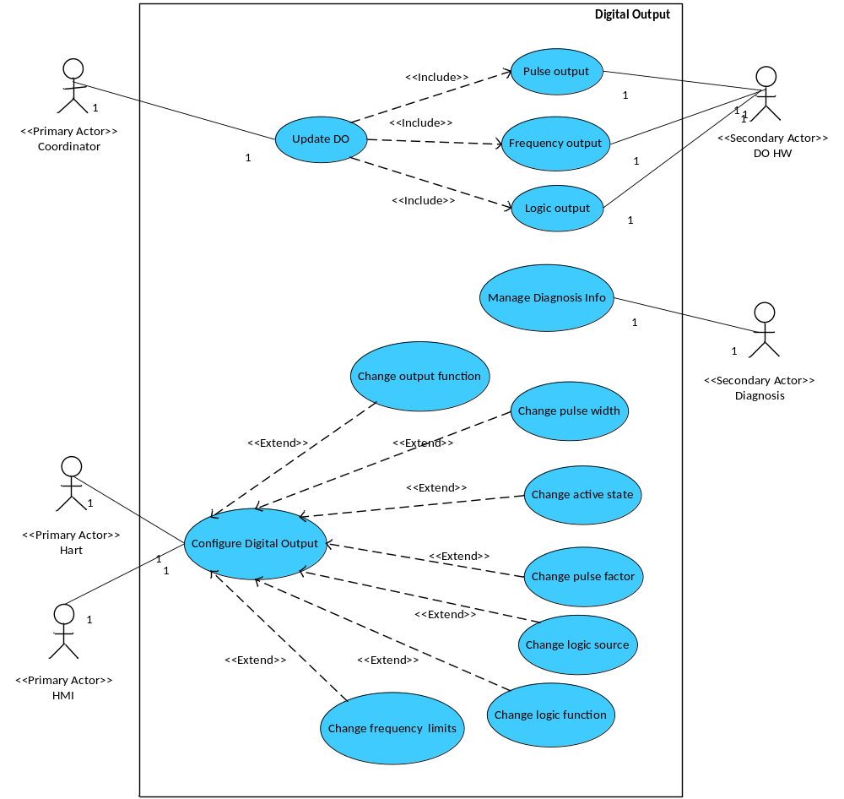
Figure 1: Use Case Diagram for Digital Output Subsystem

Subsystem Definitions

Term | Definition
Diagnostic Subsystem | VT5 subsystem responsible for handling error conditions and warnings. Also provides General Alarm data for the Digital Output subsystem.
Digital Output Subsystem | VT5 subsystem for providing output signals (eg: for pulse output or logic output) to external hardware.
HART Subsystem | VT5 subsystem for interfacing to HART (Highway Addressable Remote Transducer) protocol communications.
HMI Subsystem | VT5 subsystem providing Human Machine Interface for local user access via display and key input.
NV-RAM Subsystem | VT5 subsystem responsible for read / write access and maintenance of non-volatile memories (in transmitter and sensor).
MVM Subsystem | VT5 subsystem for providing volume/mass and operation mode to local user and other subsystems. UOM Subsystem supports the Digital Out with the Units Conversion Factors.

Acronyms and Abbreviations

DO | Digital Output
VT5 | Vortex Flowmeter
fwd | Forward
HART | Highway Addressable Remote Transducer
HMI | Human Machine Interface
HW | Hardware
ISR | Interrupt Service Routine
N/A | Not Applicable
NC | Normally Closed
NO | Normally Open
NV | Non-volatile
OP | Output
rvs | Reverse
TBD | To Be Determined
uot | Units of Totalizer Unit

Data Sheet
This chapter gives an overview of important details of the subsystem. It is intended for other developers who may wish to reuse this subsystem.

Category | Item | Description
Development | Version / Status | Released
Development | Known Bugs | Not known
Development | Planned Improvements | None
HW-Platform | Type | M16C R5F363AM
HW-Platform | Clock | Oscillation clocking 3,6864MHz  CPU clocking 1.8432MHz
SW-Development Environment | Compiler | IAR M16C 3.40
SW-Development Environment | Operating System | Segger embOS for M16C version 3.28g
SW-Development Environment | Case / Code-Generation Tool | EntryTool 1.1.3
Required Resources | Operating System | None
Required Resources | HW | Hardware Timers:  - Frequency timer (Timer B2) is used for the generation of the base frequency.  - Pulse count timer (Timer A0)  - Pulse width timer for flow (Timer A4)  - Frequency Timer (Timer A1) is used to justify the freq out  1 Port pin configured as:  - OP1 – logic output or pulse output
Required Resources | RAM | Refer to section on Memory Usage. The breakdown is:  Diagnostic data: 1Bytes  Configuration data: 2Bytes  Private subsystem data: 109Bytes  Total = 112Bytes
Required Resources | NVRAM (Plant) | Refer to section on Memory Usage:  DO Subsystem Configuration data: 47Bytes  Pulse-output specific configuration: 34Bytes  Total = 81Bytes
Required Resources | ROM | None
Required Resources | Execution Time | Method Name | Min time | Max time | Average Time
Required Resources | Execution Time | Execute(at 2kHz Output) | 3ms | 5ms | 4ms
Required Resources | Subsystems | 1.MVM,  2.UOM,  3.Diagnostics  4.Totalizer
Required Resources | Data Objects | 1.Qmax (l/s) (from MVM subsystem)  2.Units Conversion Factor (from Totalizer subsystem)  (Pulse Factor will be in kg/l if the selected Totalizer Unit is of  Type mass.  3.Alarm signal status (from Diagnostics subsystem)
Standards | Safety | None
Standards | Other | The Digital Output subsystem must not “lose” pulses, when integrated via an external counter, with respect to the internal-to-VT5 Totalizer subsystem counter.
Documentation | Requirements / Use Cases | Please refer to Figure 1: Use Case Diagram for Digital Output Subsystem.
Documentation | Public Interface Description | UpdateExe(TUSIGN8 doAlmStat) method, called by the co-ordinator, in which the latest available alarm value must be passed as a parameter;
Documentation | Test Specification | Please refer [TP012]DigitalOutput Software Subsystem Test Plan

Detailed Description

Static Modelling
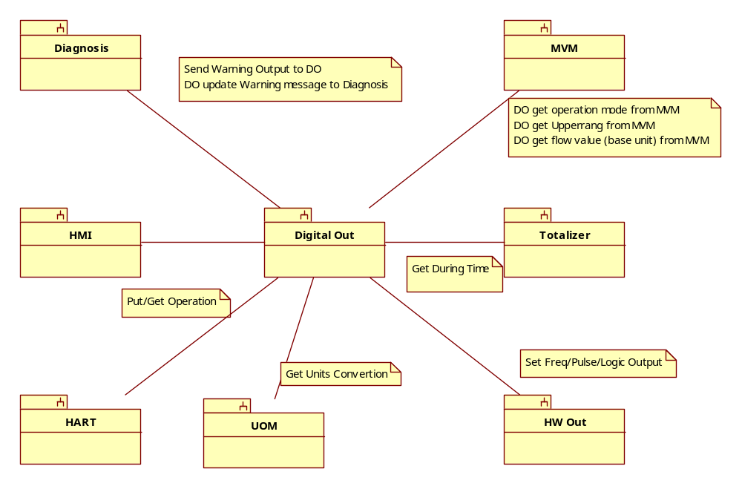
Figure 2: Context Diagram for Digital Output Subsystem

Dynamic Modelling

This collaboration diagram represents the use-case Set Logic Output. There is only 1 logic output. “Logic” in this context means any one of “General” (eg: diagnostic alarm). Execution in the sequence described, at the refresh-update-rate:

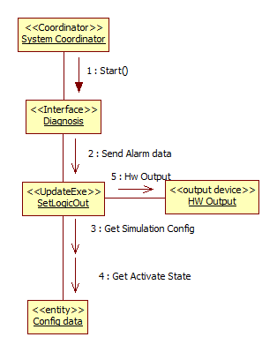
Figure 3: Collaboration diagram for Set Logic Output

This collaboration diagram represents the use-case Update Frequency output. Execution in the sequence described, at the refresh-update-rate:

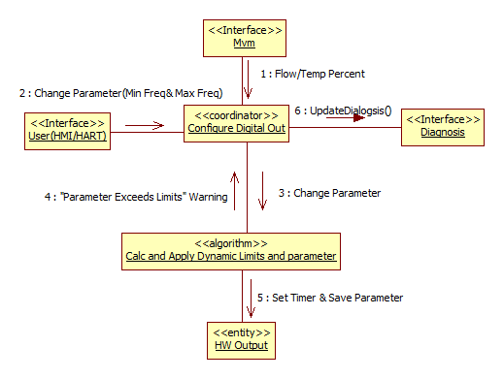
Figure 4: Collaboration diagram for Update Freq Output

The collaboration involving the algorithm “Calculate Timer Content” and “Justify Freq Output” requires further detailed explanation by the text following:

This collaboration diagram represents the use-case Update Pulse Addition Count. Execution in the sequence described, at the refresh-update-rate:

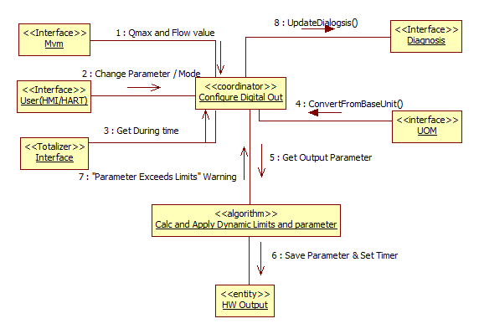
Figure 5: Collaboration diagram for Update Pulse Addition Count

The collaboration involving the algorithm “Calculate Pulse Addition Count” requires further detailed explanation by way of the following sequence diagram:

This collaboration diagram is a consolidation of all the included use-cases to Configure Digital Outputs, including “Manage Warnings”, ”Qmax Change”, “Parameter Change”, etc.
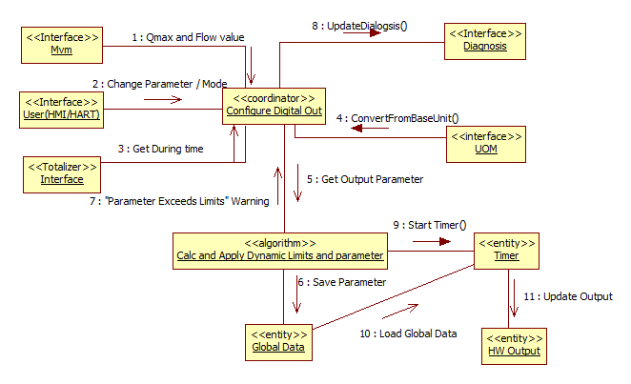
Figure 6: Collaboration Diagram for Configure Digital Outputs

To better illustrate the “Configure Digital Outputs” use-case, a table of parameter versus effect has been produced (see figure 10).

Class Design

The object-oriented design approach implies that object method calls include the address of the object’s data structure. This has not been shown in the diagrams although the C implementation requires the address to be supplied manually. The parameter for this is referred to as the “me” pointer.
eg
TUSIGN16 Get_T_UNIT (const T_UNIT SLOW *me, TUSIGN16 objectIndex,
TINT16 attributeIndex, void FAST *ptrValue);

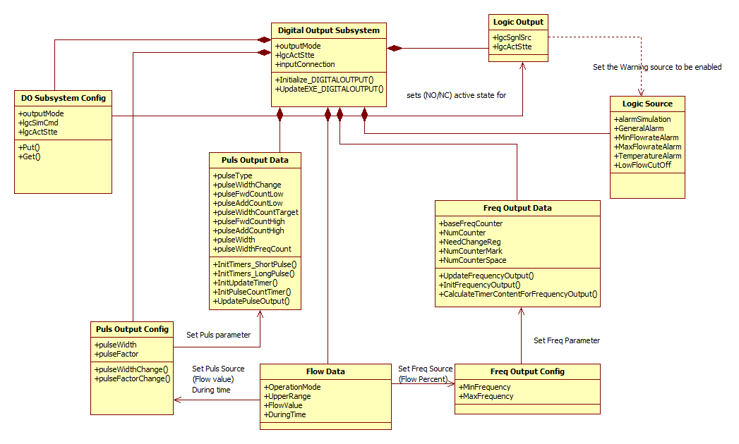
Figure 7: Digital Output subsystem class diagram

Detailed Design
It is possible at this stage to consolidate the collaboration of the main-thread “action” use-cases. Therefore this diagram depicts the activities within the Set Logic Output and Update Pulse Addition Count co-ordinator objects. The sequences from the two collaboration diagrams are mapped to this diagram for clarity:

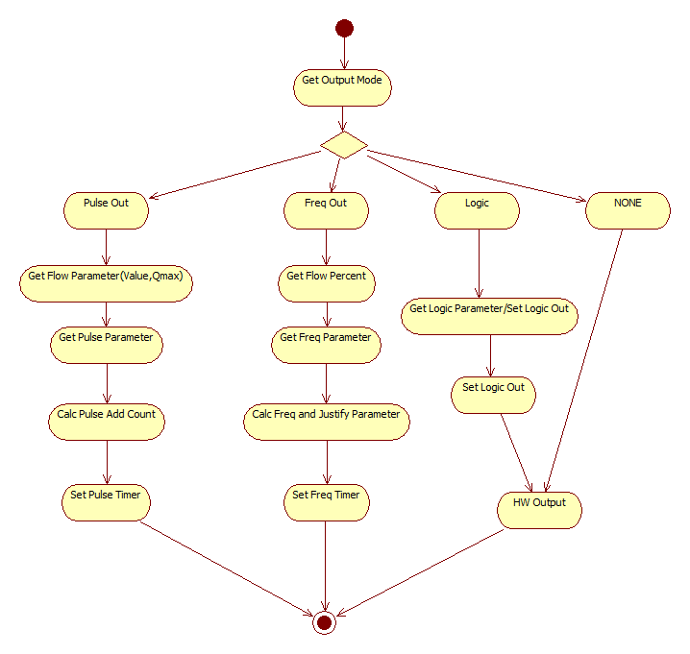
Figure 8: Activity diagram for Update Digital Output Actions

This diagram depicts the activity within the Update Freq Output co-ordinator object (triggered by the fast timer-interrupt). The sequences from the collaboration diagram are mapped to this diagram for clarity:
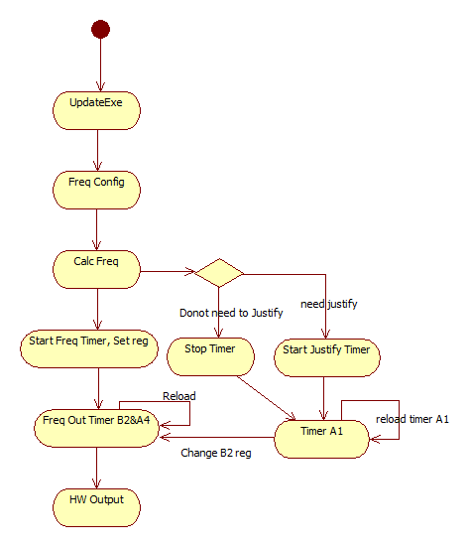
Figure 9: Activity diagram for Update Freq Output ISR

This diagram depicts the activity within the Update Pulse Output co-ordinator object (triggered by the fast timer-interrupt). The sequences from the collaboration diagram are mapped to this diagram for clarity:

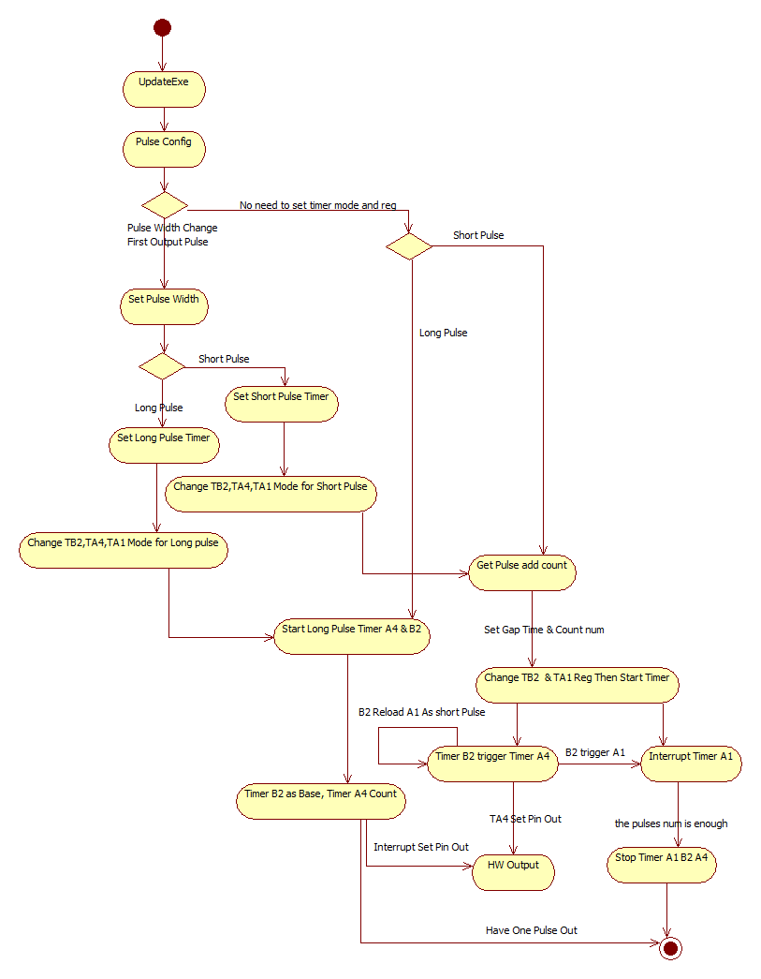
Figure 10: Activity diagram for Update Pulse Output ISR

To better illustrate the “Configure Digital Outputs” use-case, and the internal activities, a table of parameter versus effect has been produced. This shows the required limits to apply (during adjustment), and recalculation, calculations, and hardware output settings (post adjustment) that the TDigitalOutput overloaded “Put” method will need to include.

Identify the condition, and corresponding effect-code in the first table:

Parameter | Limits | Recalculations | Calculations | HW Settings
PulseWidth | Absolute Range | LimitFrequency (R1) | Pulse-width time-count (C1)
PulseFactor | Absolute Range |  | PulseFactor Range(C2)
MaxFrequency | Absolute Range | Frequency Range(R2)
MinFrequency | Absolute Range | Frequency Range(R3)

The second table then details the check performed and action required, according to the effect code:

Code | Check/Calculation performed |  | Action
Calculations
C1 | 1ms <= PulseWidth <= 1 / (2 x PulseFactor x Qmax x UnitsConversionFactor) | Can return error for condition False:  (1) Less than range min  (2) Greater than range max
C2 | If PulseOperation set for PULSE_MODE:  FullscaleFreq = PulseFactor / Qmax x UnitsConversionFactor | Changed FullscaleFreq value to be saved in NV (Plant)
Recalculations
R1 | (2 x PulseFactor x Qmax x UnitsConversionFactor) <= pulse max rang
R2 | Freq Range Low <= MinFrequency <= MaxFrequency
R3 | Freq Range Low >= MaxFrequency >= MinFrequency

Design Decisions and Limitations

The Digital Output Subsystem is designed for use with the ABB BUI Common Framework running with Segger embOS operating system. Update times for this system in the VT5 system is to be nominally 100ms.

Frequency generating algorithm

The frequency generation algorithm includes the following aspects:

- The timer hardware register is updated for frequency generation only every 100 ms.
- Extended timer is used in order to increase the precision to compensate for the shorter update interval

The coordinator will cyclically (every 100 ms) call the UpdateEXE method of the digital output subsystem in order to pass the most recent flow percent. Because the precision is required very high, in case the frequency too high, the timer lose one count will cause the loss of precision. So Extended timer source is used to compensate the loss count. The calculation is mainly in the function “CalculateTimerContentForFrequencyOutput”. First the calculation gets the pulse num in about 20ms (1/50 s, also we could change the time), then gets the pulse numbers to output long pulse and short pulse. Then these values from the calculation will be used by the timer to set the hardware output.

Pulse generating algorithm

The pulse generation algorithm includes the following aspects:

- The timer hardware is reprogrammed for pulse generation only every 100 ms.
- Extended pulse addition count to 64 bits in order to increase the precision to compensate for the longer update interval

The coordinator will cyclically (every 100 ms) call the UpdateEXE method of the digital output subsystem in order to pass the most recent flow rate. From this flow rate a 64 bit addition count will be calculated which is further processed in the UpdatePulseOutput function. From this addition count and the further 64 bit accumulator (for flow) the number of pulses to be generated will be calculated. Following that, the method SetDigitalOutputPulses will be called and reprogram the timers to generate the desired number of pulses with the selected pulse width.
In addition to that the total time for generating the complete pulse packet will be calculated. In case the time to output the pulses is longer than 100 ms window, a gap time will be derived that is used to add a delay for the pulse generation of the following window.

Gap [ms]
100
200
300
400
0
Time [ms]
40
40
Digital Long Pulse Output Signal (40 ms pulse width, 100% flow)
Voltage
0
60
40
20
0

Limit Pulse factor Dynamic Limits

Within the subsystem configuration, the limit Pulse factor value limits are to be handled differently from all other configuration parameters, which are subject to fixed low and high limits.

A description of the limit frequency affecting factors is given in the Digital Output Subsystem Requirements Specification. Methods are to be provided to accommodate the different limiting behaviour required to achieve this. The interpretation should be:

Pulse factor is to be dynamically limited according to the following:

Pulsefactor (HiLim) <=1000/( Fullscale frequency * 2 * pulseWidth)

Changes to the pulse Width that result in the limit Pulse factor exceeding the (re-) calculated dynamic limit should result in the Pulse factor value being changed (set equal to the dynamically calculated (HiLim) limit).

Limit Pulse Width Dynamic Limits

Within the subsystem configuration, the limit pulse width value limits are to be handled differently from all other configuration parameters, which are subject to fixed low and high limits.

A description of the limit frequency affecting pulse width is given in the Digital Output Subsystem Requirements Specification. Methods are to be provided to accommodate the different limiting behaviour required to achieve this. The interpretation should be:

Pulse width is to be dynamically limited according to the following:

PulseWidth (HiLim) <= 1000/( Fullscale frequency * 2 * pulseFactor)

Changes to the pulse factor that result in the limit Pulse width exceeding the (re-) calculated dynamic limit should result in the Pulse width value being changed (set equal to the dynamically calculated (HiLim) limit).

Parameter configuration algorithm

The current implementation of the digital output subsystem allows the user to configure the following parameters that influence the behaviour of the pulse output:

- Maximum flow value Qmax
- Unit of the MVM flow value
- Pulse factor (pulses per flow volume in pulse mode)
- Pulse Range
- Pulse width (length of the pulse in milliseconds)

In the following scheme a parameter change leads to a recalculation of the associated parameter ranges from top to bottom. If one of the associated parameters is now out of its range, the actual value is adjusted to the closest value inside the range and an alarm is generated to indicate the automatic parameter update to the user.

Range and value update dependencies after parameter change:
1ms <= PulseWidth <= 1000 / (2 * PulseFactor * UnitConv * Qmax)
Range
MVM
Range
Pulse Factor
Actual Value
Range
Pulse Width
Actual Value
Range Qmax
MVM
Upper range Value
Range
Pulse Range
Actual Value
0.25 <= Pusle Factor * (Qmax * UnitConv) <= Fullscale Frequency
0.0001 <= PulseFactor <= Fullscale Frequency / (Qmax * UnitConv)
Units Change: the Qmax would not affect the Range, but affect the actual value change from base-unit
Actual Value

Hardware Dependencies

The Digital Output subsystem has direct dependency on hardware. The requirement is to address hardware port directly as output.

In respect of memory, the actual storage of settings and values to NV memory is looked after by a Common Framework compatible NV handler subsystem external to the Digital Output subsystem.

Memory Usage
The tables below define the memory usage for the Digital Output subsystem.

Digital Outputs Subsystem Configuration
Instances | Object Name | Type | Area | Description / Limits
Singular | alarmState | TENUM | Dynamic | Alarms to be represented as logic outputs by the digital output subsystem.
# =  OP1 | outputMode_# | TENUM | NV | Output mode of hardware output #; possible settings:  0 – NORMAL  1 – LOGIC_SIMULATION  2 – PULSE_SIMULATION  3 – FREQ_SIMULATION
# =  OP1 | inputConnection_# | TENUM | NV | Output value source for hardware output #;  possible settings:  0 – NO_CONNECT  1 – FLOW_CONNECT  2 – TEMP_CONNECT
# =  OP1 | lgcSgnlSrc_# | TENUM | NV | Logic signal source for hardware output #; possible settings:  0 – NO_SIGNAL_SOURCE,  1– GENERAL_ALARM
# =  OP1 | lgcActStte_# | TENUM | NV | Logic action state for hardware output #; possible values:  0 – NORMALLY_OPEN  1 – NORMALLY_CLOSED

TFrequencyOutputData
Instances | Struct Members | Type | Area | Description / Limits
Singular | baseFreqCounter | TUSIGN16 | Private | TB2 register
Singular | NumCounter | TUSIGN16 | Private | TA4 register
Singular | OldTA1Status | TUSIGN8 | Private | Is TA1 started
Singular | NeedChangeReg | TUSIGN8 | Private | should TA1 be enabled
Singular | SpaceNow | TUSIGN8 | Private | TB2 work status(Output long or short)
Singular | NumCounterMark | TUSIGN32 | Private | TA1 delay time for Long width
Singular | NumCounterSpace | TUSIGN32 | Private | TA1 delay time for Short width

TPulseOutputData
Instances | Struct Members | Type | Area | Description / Limits
Singular | pulseFwdCountLow | TUSIGN32 | Private | Forward-pulses rollover-counter
Singular | pulseAddCountLow | TUSIGN32 | Private | Addition count
Singular | fwdPulseWidthCounter | TUSIGN16 | Private | Forward long pulse-width counter
Singular | pulseWidthCountTarget | TUSIGN16 | Private
Singular | pulseFactor | TFLOAT | Private | Units-of-totalizer conversion factor from external subsystem
Singular | pulseFwdCountHigh | TUSIGN32 | Private | Forward-pulses rollover-counter
Singular | pulseAddCounHigh | TUSIGN32 | Private | Addition count
Singular | pulseWidth | TFLOAT | Private | Actual pulse width in ms

Data Object Description

Data Object | Use / Type / Range / Default / Storage
alarmState_DO
  Use | Local digital output alarm.
  Type | Enumeration list.
  Range | DIGITALOUTPUT_ALARM_BEHAVIOUR_OK  DIGITALOUTPUT_ALARM_BEHAVIOUR_FAIL_LOGIC_OUT_1
  Default | DIGITALOUTPUT_ALARM_BEHAVIOUR_OK.
  Storage | Dynamic
outputMode
  Use | Current output mode.
  Type | Enumeration list.
  Range | DIGITALOUTPUT_DO1_NONE  DIGITALOUTPUT_DO1_LOGIC  DIGITALOUTPUT_DO1_PULSE  DIGITALOUTPUT_DO1_FREQUENCY
  Default | DIGITALOUTPUT_DO1_NONE.
  Storage | NV (Plant data)
simuEnabled
  Use | Simulation function switch.
  Type | Enumeration list.
  Range | Choice of:  DIGITALOUTPUT_SIMU_DISABLED,  DIGITALOUTPUT_SIMU_ENABLED
  Default | DIGITALOUTPUT_SIMU_DISABLED
  Storage | Dynamic
lgcSgnlSrc
  Use | Logic output indication source.
  Type | Enumeration list.
  Range | DIGITALOUTPUT_NO_LOGIC_SOURCE,  DIGITALOUTPUT_DIGITAL_OUTPUT_ALARM
  Default | DIGITALOUTPUT_NO_LOGIC_SOURCE
  Storage | NV (Plant data)
lgcActState
  Use | Logic output active state.
  Type | Enumeration list.
  Range | DIGITALOUTPUT_ACTIVE_HIGH,  DIGITALOUTPUT_ACTIVE_LOW
  Default | DIGITALOUTPUT_ACTIVE_HIGH
  Storage | NV (Plant data)
pulseWidth
  Use | Pulse width
  Type | FLOAT_FIXEDUNIT.
  Range | pulseWidthRange,
  Default | 20
  Storage | NV (Plant data)
pulseFactor
  Use | Pulse factor.
  Type | pulseFactorRange.
  Range | 0.25
  Default | 20
  Storage | NV (Plant data)
pulseFactorRange
  Use | Pulse factor range.
  Type | FLOATRANGE_FIXEDUNIT.
  Range | 0.001 – 2000.0
  Default
  Storage | NV (Plant data)
pulseWidthRange
  Use | Pulse width range.
  Type | FLOATRANGE_FIXEDUNIT.
  Range | 0.05ms-2000ms
  Default
  Storage | NV (Plant data)
simuFrequency
  Use | Frequency for simulation.
  Type | Float.
  Range | 0.25-10000.0
  Default | 10500.0
  Storage | NV (Plant data)
minFrequency
  Use | Low limit frequency.
  Type | FLOAT_FIXEDUNIT.
  Range | minFrequencyRange
  Default | 0.25
  Storage | NV (Plant data)
maxFrequency
  Use | Upper limit frequency.
  Type | FLOAT_FIXEDUNIT.
  Range | maxFrequencyRange
  Default | 10500.0
  Storage | NV (Plant data)
minFrequencyRange
  Use | Low limit frequency range.
  Type | FLOATRANGE_FIXEDUNIT.
  Range | 0.25-10500.0
  Default
  Storage | NV (Plant data)
maxFrequencyRange
  Use | Upper limit frequency range.
  Type | FLOATRANGE_FIXEDUNIT.
  Range | 0.25-10500.0
  Default
  Storage | NV (Plant data)
alarmSimulation_DO
  Use | Digital Output local simulation alarm.
  Type | T_DIAGNOSIS_ALARM (8bits).
  Range | DIGITALOUTPUT_PULSENUMMAXALARM
  Default | 0
  Storage | NV (Plant data)
simuPulsesNum
  Use | Pulse number for simulation.
  Type | INT16.
  Range | 0-10000
  Default | 100
  Storage | NV (Plant data)

References
Ref. | Document
[1] | [RS011]Software Subsystem Requirements Specification DigitalOutput
[2]

Revision History
Rev. | Description of Version/Changes | Primary Author(s) | Date
0.1 | Initial revision. (Draft) | Georg Horst | 2007-05-30
0.2 | VT5 One DO version | Paul Li | 2011-10-11
0.3 | Revise use case diagram and add data object description. | Vincent Liu | 2013-06-26
0.4 | Update some typos in section 2 | Vincent Liu | 2013-12-06

Design Review

Review-Participant:
Dept. | Name
R&D  ShangHai | Lawrence Shi, Tongkun Liu | 2013-06-26 rev 0.2
R&D  ShangHai | Lawrence Shi, Tongkun Liu | 2013-07-05 rev 0.3
R&D  ShangHai | Merrick Huang | 2014-01-06 rev 0.4

Decision of the Review:
 | Decision | next steps
x | Inspection passed without restrictions | Phase finished
 | Inspection passed with restrictions | some changes must be done
 | Inspection not passed | Inspection must be repeated

Check list:
 |  | Yes | No
1. | Is the software architecture distinct and documented? | X
2. | Fit the modules together? | X
3. | Are complex algorithms/procedures explained? | X
4. | Is a strategy for error handling designated? | X
5. | Is the configuration management system well prepared? | X
6. | Are all open issues transferred to the defects table? | X

Remarks:

Defects
No. | Checkpoint | Description | Major  defect | done  Date
1 | Chapter 3.9 | Remove data object inputconnection | N | 2013-07-04

Changes are proved:
The Reviewer confirms that all changes are done:
proved Rev: | Date: | Reviewer:
0.3 | 2013-07-05 | Lawrence Shi, Tongkun Liu
0.4 | 2014-01-06 | Merrick Huang

